**Dual DC motor driver module, forward or reverse, PWM speed control, dual H-bridge stepper motor, mini, beyond L298N**

Description: motor drive module is ideal for use in battery-powered smart car, toy cars, robots. Supply voltage 2V ~ 10V, can drive two DC motors or a 4-wire 2-phase stepper motors ,can achieve forward rotation or reverse rotation, it is possible to adjust the rotation speed. Each can provide continuous current of 1.5A, peak current up to 2.5A, thermal protection and can be automatically restored.

**Product Highlights:**

1. Use of imported original chip, built-in low on-resistance MOS switch, minimal heat, no heat sink, small size, low power consumption, is ideal for battery powered.

(L298N internal transistor switch, low efficiency, high fever, need to add heat sink, bulky, L298N very easy to burn)

2. Dual 1.5A * 2, the peak current to be 2.5A, built-in thermal protection circuit, do not be afraid motor stall burned, automatic recovery after the temperature dropped.

3. Small size, light weight, 0 standby current, is the ideal choice for your car model.

[Attach function diagram]

INx connected to the MCU I / O port, MOTOR-A and MOTOR-B is connected to the motor.

DC motor drive logic truth table:

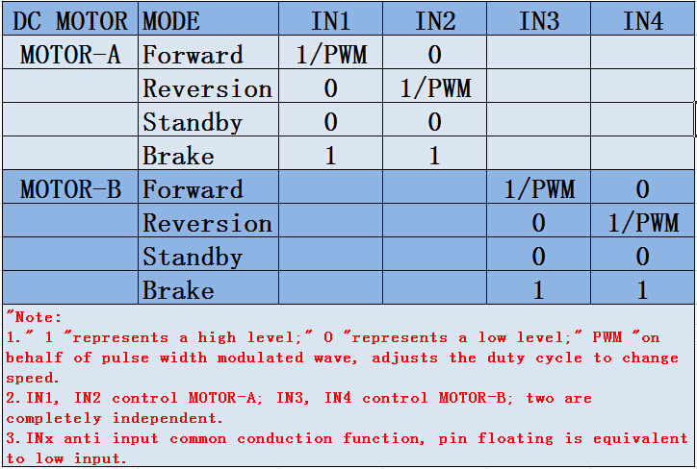

**Product parameters:**

1. Dual H-bridge motor driver, can drive two DC motors or a 4-wire two-phase stepper motor;

2. The module supply voltage 2V-10V;

3. Signal input voltage 1.8-7V;

4. Single Operating current 1.5A, peak current up to 2.5A, low standby current (less than 0.1uA);

5. Built-in common conduction circuit, when the input pin is left floating, the motor does not malfunction;

6. Built-in thermal protection circuit with hysteresis effects (TSD), without worrying about motor stall;

7. Product Size: 24.7 * 21 * 5mm (length, width, height), ultra-small size;

8. The mounting hole diameter: 2 mm.

9. Weight: 5g

**Precautions:**

1. Power positive and negative reversed will certainly cause damage to the circuit.

2. Output is shorted to ground or output short circuit, and the motor stall, the chip will heat protection, but in the near or exceeding 10V voltage and peak current is greater than 2.5A situation can also cause chip burned.